1.Overfitting → Dropout
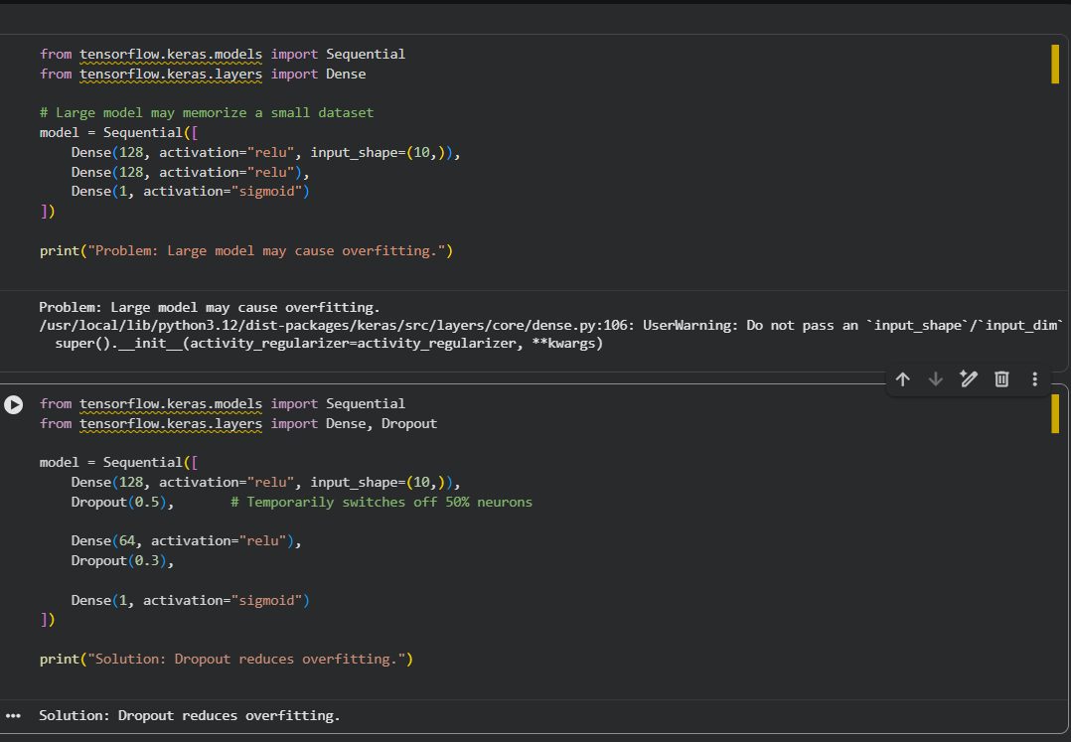

2. Underfitting → Larger Model and More Training
